**HUMAN OBJECT TRACKING USING CAMSHIFT ALGORITHM**

**Rizki Putra Utama Endriansyah 1, Danang Aditya Nugraha 2, Akhmad Zaini 3**

Informatics Engineering, Universitas PGRI Kanjuruhan Malang1,2,3

[rizkiutama379@gmail.com](mailto:rizkiutama379@gmail.com)1, [d4n4ng.adty@gmail.com](mailto:d4n4ng.adty@gmail.com)2, [Ahmad_zaini21@yahoo.com](mailto:Ahmad_zaini21@yahoo.com)3

|  |  |  |
| --- | --- | --- |
| **Article Info** |  | **ABSTRACT** |
| ***Article history:***  Received Okt 27, 2017  Revised Dec 21, 2017  Accepted Jan 3, 2018 |  | Learning technology continues to evolve with the evolution of the times. Hybrid learning is a learning method that leverages the benefits of face-to-face (offline) classroom learning and distance learning. (online). When using video conferencing services on hybrid learning, speakers tend to be unable to keep quiet during learning or to be told the speaker's position changes, so the camera does not capture with good results because the camera is generally static. The technology often used to make a computer recognize objects is computer vision in its field there are objects tracking in computer vision. Camshift is a color-based object-tracking algorithm capable of tracking partially or entirely covered objects under certain conditions. Therefore, make a framework using the Camshift algorithm with a servo motor drive connected to an Arduino pin that will then move the camera according to the presence of the target object. |
| ***Keyword:***  Camshift Algorithm  Human Object Tracking  Hybrid Learning  Computer Vision  Object Tracking  IOU (Region of Interest) |
| *© This work is licensed under a Creative Commons Attribution-ShareAlike 4.0 International License.* |
| ***Corresponding Author:***  Corresponding Author  Department of Electrical and Computer Engineering  xxxx University  Address, City, Country  Email: xxx@xxxx.xx.xx | | |

# INTRODUCTION

The development of information and communication technology has spread to many areas of life, including education[1]. In the world of education that continues to evolve with the times, many are beginning to apply information and communication technology in the learning process. In the application of learning that uses information technology and communication is the only method of learning hybrid[2].

Hybrid learning is a learning method that utilizes information and communication technology in the field of education by taking advantage of more flexible advantages in learning.[3]. Hybrid learning combines two methods of learning: offline classroom and online distance learning. In hybrid learning, students can be followed offline or engaged in distance learning activities via video conferencing services. [4].

Good hybrid learning can be achieved when the student or student gets the entire activity taught by the speaker from learning through face-to-face classes (offline) or distance learning (online) [5]. When doing hybrid learning, speakers tend not to be able to stay quiet while learning or can be told speaker positions change, so the camera does not capture good results[6]. Basically, when learning a hybrid classroom, you don't have to interfere much with the system so that the learning activity goes well.[7].

Webcams are generally static so that at the time of learning involve interference with the system so that learning activity is interrupted. Improved media or means and facilities are intended to reduce and overcome the difficulties experienced by teachers or lecturers and students or students during hybrid learning. A commonly used method that can identify and track speaker movements automatically using a camera is Computer Vision.[8]. Computer vision is part of artificial intelligence that focuses on how computers can understand, recognize, and process visual data from images or videos like humans.[9]. Computer vision has a variety of methods ,one of them is objects tracking

Object tracking is a method that detects an object captured by the camera at the start of a running program, then locks the target, marks and follows the moving object.[10]. Continuously Adaptive Mean Shift (Camshift) is a color-based object tracking method algorithm that is excellent in recognizing objects.[11]. Camshift is a developmental algorithm of the Meanshift algorithm, using color histograms and adjusting the size of objects to be scaled.[12]. In addition, the Camshift algorithm has a fast computing time and, can perform real-time tracking and is able to track partially or completely closed objects under certain conditions.[13]. The Camshift algorithm is used in the detection of coloured objects with high accuracy and is matched in combination with other Algorithms[14].

Taking into account what has been described in the background above, the author uses a Camshift algorithm with a webcam powered by a servo motor connected to an Arduino pin so that it can track automatic human movements.

# RESEARCH METHOD

Research begins with a study of literature from a variety of sources, including literature, scientific journals, and related final assignments. Then, analyze the needs that will be used and make a system design to support the research and toolmaking process. The next step is to test the system to evaluate the performance of the system that has been developed. The stages of the study are illustrated in Figure 1, which covers a series of processes carried out during this study.



Figure 1 Research Procedures

The research process begins with literature studies, which searching for journals and articles related to human object tracking using the Camshift algorithm, continues with needs analysis, including analysis of input needs, process needs analysis and output needs, then proceeds with the design of human objects tracking system using the camshifts, after which the system will be tested with the aim of knowing the performance of the system.

## Literature Studies

A library study was conducted to gather a broad and in-depth understanding of human object tracking using Camshift algorithms from various relevant sources, such as literature, scientific journals, and final assignments, in order to gain a comprehensive insight into the research topic.

## Resource Analysis

System resource analysis consists of identifying the needs and measures required in tracking human objects using the Camshift method, taking into account input, process, and output needs to ensure that the system can meet well-defined goals and needs.

## Tool Planning



Figure 2 Tool Planning Diagram

Figure 2 shows a tool design diagram that aims to facilitate the overall analysis of the system design in conducting a system simulation. The system design began with the use of a camera to read data. The data captured by the camera will be transmitted via a wireline connection to the laptop. The data will then be processed, and the laptop will send the data to the Arduino Uno via a Wireline connection.[15]. Figure 2 shows the design of the instrument in this study.

## System Planning



Figure 3 System Planning Flowchart

Figure 3 describes steps in the system that include pre-processing, backprojection calculation, boundary point determination, application of the Camshift algorithm, calculation of servo drive control, and data collection of detection results. The process begins with taking image input from the first frame of the video. The output is a camera that can move to track a marked human object, as well as tracking coordinate history data stored along with the system detection video recording in.MP4 format.

## Servo Driver Control

After tracking with the Camshift method, the coordinate value of the target of the detection object will be obtained which will be used as a reference to the movement of the servo motor. The rule of this servo movement is determined by the boundary point initialized manually[16] When the detected object passes or touches the bridge then the server will move. The result of this process is the camera's ability to perform horizontal movements, following the movement of the target object in the 0° to 180° angle range.



Figure 4 Control Servo

## Testing

Tests are carried out to check the compatibility of the device used with the desired expectations [8]. The system is tested in bright and dim conditions[16], with test results that cover a variety of parameters such as photo quality, frame rate, and resolution [17], [18]. The system was also tested to ensure that the function was in line with the system's command, while the servo motor was tested to measure the degree of rotation according to the system's command.[15].

### System Prediction Testing

System prediction testing on human objects is used to determine the accuracy of systems made using the IOU method. (Intersection Over Union)[19]. In obtaining the IOU value, the system compares the prediction tracking box with the tracking boxes that should be[20]. The first step is to divide the prediction result tracking box and the track box that should be sliced. Then, the two tracking boxes are merged. Next, the system divides the slicing area by the combined area according to the IOU equation. If the IOU value is below 0.4, the matching is considered failed, whereas if the value is above 0.4, the system can predict the object well.[21].

### Overall System Testing

Tests are conducted to evaluate the performance of the system developed using the function of the IOU (Intersection Over Union) method by initializing the x, y, w, and h coordinates of the intended target object, with dimensions of length, width, and height corresponding to the location of the traced object. The initialization results are then saved, involving the merging of the boxes of boundaries and the intending object tracking boxes, followed by the division of the section area by the combined area in accordance with the IOU equation. This aims to understand how well the system can track objects accurately using the IOU method.

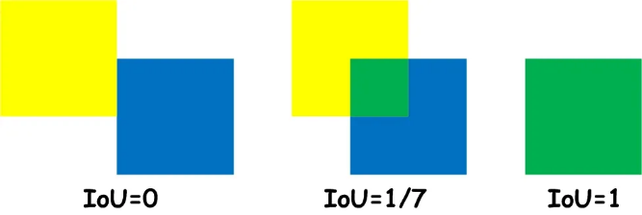

Figure 5 IOU Working System

IOU uses the value obtained if the object is not in the tracking box whose value should be 0 [22]. In this study it is used as an error detection so that if the object is outside the boxes or is not within the range of the camera then it will have a value of 0 the measurement can be seen on the equation as follows:

To determine the accuracy of each running system or when the system is operating can be counted with the following equation:

# RESULTS AND ANALYSIS

## System Implementation

This research has produced a human tracking system that uses the Camshift algorithm. The system consists of several components, including a webcam unit as an image/video input source, Arduino as a control to move the servo motor that controls the motion of the camera horizontally, and the laptop as the primary control that implements the tracking algorytm and sends instructions to the arduino, with a combination of these components the system can perform real-time tracking of humans using the Comshift algoritm..

## Hardware Design Results

Here is the implementation of the human object tracking research objects application using the Camshift algorithm implemented by applying hardware design in three-dimensional form:

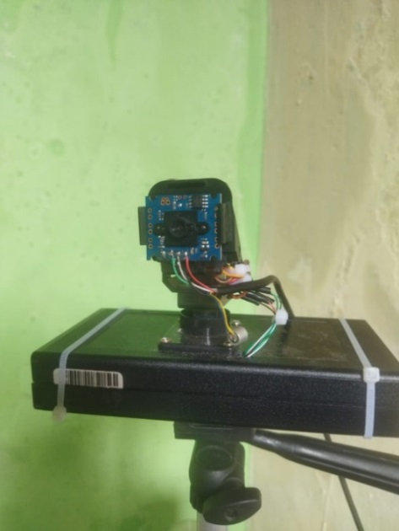

Figure 6 Hard Device

## Software Planning Results

### Tracking Location Initiation

At the initiation stage, location tracking involves the preparation of input data, with the target object being a human face moving in front of the camera. The input data is a real-time video, taken per-frame when the system captures. To ensure the direct use of data from the webcam camera with the system that can be used directly, a value of 0 is used on the code line "cap = cv.VideoCapture(0)", indicating the use of the main camera on the device. At this stage, the camera is accessed to take a video and convert it into a webcam frame used as a parameter, thus obtaining a snapshot of the RGB color image as shown in the picture.

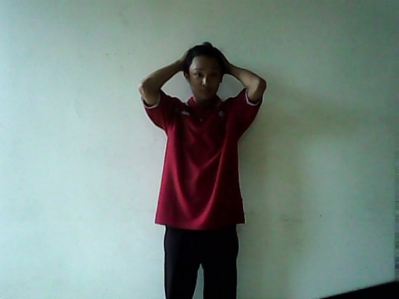

Figure 7 RGB Color Image Shaped Frame Capture Results

After obtaining input data through a snapshot, the next step is to determine the target object to be tracked on the snapshot frame with manual initialization, in which the input data comes from a webcam size of 640 x 480 pixels, and the coordinates of the objects to be traced are determined manually by selecting the shirt wearing on humans using the "cv.selectROI" function of OpenCV, which produces x, y, w, and h coordinates grouped into an array.

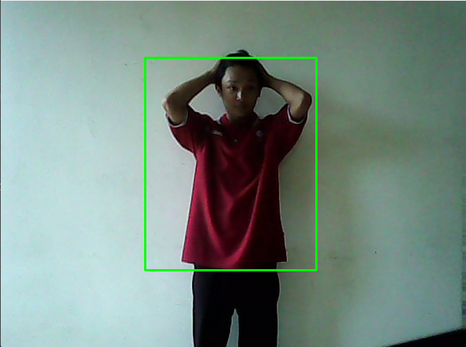

Figure 8 Tracking location setup results.

### Pre-Processing

In the pre-processing process the first step is to obtain the coordinate position of the target object to be detected performed through the ROI variable, in which the frame of the real-time video input is taken and set to [y:y+h, x:x+w], i.e. the location of the object target or cordinate to be cut. Thus, this process makes it possible to obtain a portion of the frame that contains the target object to be further analyzed. Figure 9 below shows the result of cutting colored image objects.



Figure 9 Image Cutting Results

The ROI conversion process from BGR to HSV is done to enable the system to differentiate the image of the selected object more clearly in light intensity changes, using the color criteria of the shirt on the human body. In OpenCV, the color image is presented in the BGR format, so that the system performs the conversion to the HSV for better analysis, enabling the detection of the color of the cloth in humans more effectively in a variety of light conditions.

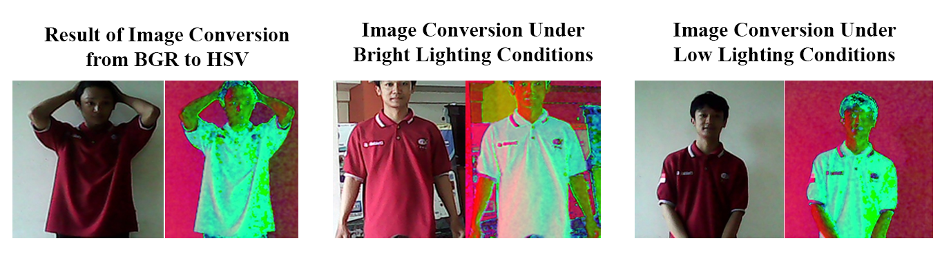

Figure 10 BGR2HSV Image Conversion Results

After converting RGB colors to HSV colors, the system performs the segmentation process, commonly known as masking, in OpenCV. The mask_roi variable is filled using the "inRange" function with images in the HSV color space as the first parameter, while the second and third parameters determine the bottom and upper boundaries in the form of a tuple, using the NumPy library. This masking process depends on the threshold value obtained from previous research, effectively separating the selected object from the background or other object in the image.

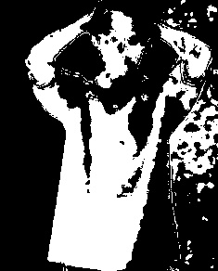

Figure 11 Color Segmentation Process Results.

In this case study, the system determines the object based on the colour of the shirt used by the object by ignoring the background around the object. In Figure 11 below, the webcam detects that the human skin color is the same as the shirt color used, so the color is included in the colored image object.

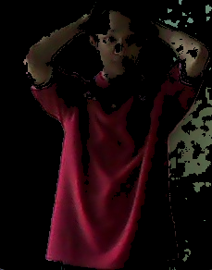

Figure 12 Threshold Usage Result

Histogram calculation in OpenCV using the "calcHist" function. The "roi_hist" variable is filled with images in the HSV color space, with the hue channel taken as the first channel (ditunjukkan dengan angka 0). The mask used is derived from the previous segmentation process, and the histogram measurements start from 0 to 180 to avoid density on other objects in the image being processed. The next stage is the normalization of values using the "normalize" function, where the source is the "roi_hist" variable. The aim is to reduce the range of values to 0-255 by normalizing min-max, so that it can speed up the learning process on classification by reducing the impact of too large values on features that influence the classification process.

### Determining Criteria Boundary

In this phase, the application of the Camshift method to detect target objects on the next frame is limited to a maximum of 10 iterations or moves to a higher pixel density region, at least 1 point. This is done by defining the "term_crit" variable.

### Initiation of Border Point Coordinates

After generating ROI data for colored objects, the next step is to set the boundary point coordinates. The purpose of this step is to limit the area where the traced object must be within camera reach. In this study, using a webcam with a resolution of 640 x 480 pixels, the boundary point coordinates on the frame were set as x = 42, y = 3, w = 561, h = 477. Figure 13 below illustrates the result of the determination of the boundary point coordinates.

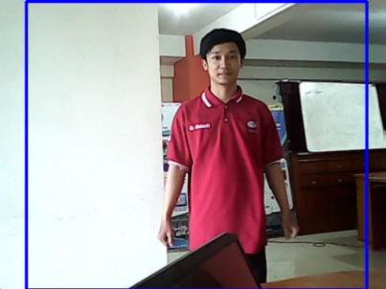

Figure 13 Results Determining Boundary Point Coordinates

### Camshift Algorithm Object Tracking

The Camshift algorithm requires color conversion to the widest hsv first, and the back projection calculation is performed on the system by taking a component or channel hue from the HSV color space. Then, after the calculation process is completed, it is necessary to apply the Comshift algorithm by reading data from the webcam and reading and giving a target tracking mark in the form of a prediction box on the frame.

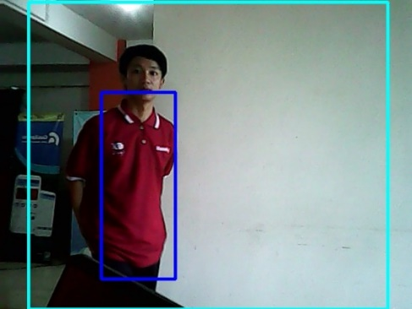

Figure 14 Object Tracking Results

## System Tracking Scanning

In testing the tracking system, the authors selected four samples of frames from the test video, namely the 73, 377,474, and 835 frames, while to evaluate the object detection model, they used the IOU method that utilizes bounding boxes on the system detection result frame.

Table 1 System Predictor Results

| *Frame* | Picture | System Prediction | | | | Ground Truth | | | | IOU Value |
| --- | --- | --- | --- | --- | --- | --- | --- | --- | --- | --- |
| X | Y | W | H | X | Y | W | H |
| 73 | gambar1 | 225 | 136 | 122 | 310 | 172 | 140 | 170 | 282 | 60% |
| 377 | gambar2 | 33 | 159 | 164 | 282 | 32 | 148 | 177 | 286 | 87% |
| 474 | C:\Users\Administrator\Documents\unikama\skripsi\SKRIPSI\program1\record\gambar3.jpg | 305 | 172 | 169 | 284 | 310 | 167 | 153 | 252 | 77% |
| 835 | C:\Users\Administrator\Documents\unikama\skripsi\SKRIPSI\program1\record\gambar.jpg | 70 | 144 | 204 | 291 | 80 | 162 | 174 | 247 | 72% |

Table 1 shows that the system is able to track colored objects with IOU values above 40% using four-frame samples from the test video, including the 73, 377, 474, and 835 frames.

To assess the system's ability to track objects hidden by other objects, the authors chose four frames from the testing video, including the 543, 568, 591, and 602 frames, with the aim of finding out whether the system can detect objects when another object hides the traced object, especially the human object.

Table 2 System Predisk Results with Obstacles

| *Frame* | Picture | System Prediction | | | | *Ground Truth* | | | | IOU Value |
| --- | --- | --- | --- | --- | --- | --- | --- | --- | --- | --- |
| X | Y | W | H | X | Y | W | H |
| 543 | C:\Users\Administrator\AppData\Local\Microsoft\Windows\INetCache\Content.Word\gambar1.jpg | 282 | 177 | 160 | 278 | 277 | 165 | 153 | 261 | 77% |
| 568 | C:\Users\Administrator\AppData\Local\Microsoft\Windows\INetCache\Content.Word\gambar2.jpg | 324 | 159 | 65 | 209 | 227 | 190 | 154 | 265 | 22% |
| 591 | C:\Users\Administrator\AppData\Local\Microsoft\Windows\INetCache\Content.Word\gambar3.jpg | 115 | 125 | 270 | 368 | 183 | 165 | 156 | 255 | 40% |
| 602 | C:\Users\Administrator\AppData\Local\Microsoft\Windows\INetCache\Content.Word\gambar4.jpg | 96 | 158 | 203 | 285 | 126 | 161 | 168 | 253 | 73% |

In Table 2, the system is capable of tracking human objects with human obstacles with contrasting colors. On the 543th frame, the system was able to predict with an accuracy of 77%, while on the 568th frame there was a decrease in accuration due to a closed object, with an IOU value of 22%. However, on the 591-th frame after the object was closed, the systems experienced an increase in the IOUE value to 40%, and on the 602-th frame the system achieved a good IOUI value, which is 73%.

## System Overall Testing

The entire system test will be performed to determine the performance of the system developed using the working functions of the IOU method. (Intersection Over Union)[23]. The first step is to initialize the x, y, w, and h coordinates of the intended target object, the size of the length, width, breadth and height according to the location of the traced object, after which the result is saved, then the boxes of the boundary box and the tracking box of the object that should be merged, after that, the section area is divided by the combined area according to IOU equation[24].

This test was conducted to determine the performance of the entire system developed at the time of using the servo motor in its implementation. The test resulted from a video with a resolution of 640 x 480 pixels and 7 data with different datasets and lighting, the results can be seen in Table 3 below:

Table 3 System-wide test results

| No | Attributes | Number of frames | Frame Error | Lighting | Accuracy |
| --- | --- | --- | --- | --- | --- |
| 1 | Trial 1 | 1124 | 0 | 33 lux | 100% |
| 2 | Trial 2 | 2261 | 170 | 14 lux | 92% |
| 3 | Trial 3 | 1079 | 448 | 12 lux | 59% |
| 4 | Trial 4 | 697 | 0 | 13 lux | 100% |
| 5 | Trial 5 | 906 | 0 | 61 lux | 100% |
| 6 | Trial 6 | 296 | 79 | 13 lux | 73% |
| 7 | Trial 7 | 1854 | 312 | 32 lux | 83% |
| **Total** | | **8222** | **1009** |  | **88%** |

In the above test in the first test with a total of 1124 with 33 lux lighting, obtained an accuracy of 100% without frame error, with support conditions with parameter data created using Cropping_ROI contrasting with the background. Assignment with the lowest accuration with a 59% accurate value in the third test with the total of 1079 frames obtaining an error of 448 frames, due to the lack of illumination and the parameters data generated using the Cropping _ROI does not contrast with the backdrop.

Based on the results in Table 3, the system's results have been obtained with a total accuracy of 88% with 8222 frames where the results are obtaining from real-time video from a webcam, with data capture of as many as 7 data with different datasets and different criminalization.

# CONCLUSION

Based on the results of the research and testing that has been done on the human tracking system using the Camshift method can be concluded as follows Successfully designed the human tracking system with the use of the camshiff method using programming as the main programming that is run on the laptop as the principal control python of the system as well as Arduino uno acts as a mechanical control form servo with a angle of rotation 0° – 180° degrees. Using the Camshift method, since the target being tracked is a human, the colour bench is the human colour that is used. In this study, the system is able to retain the objects that are traced in human colours. The system can distinguish the object that is supposed to be traced from another object or other object even though the object being traced is covered by other objects.The highest accuracy is achieved on video with 1124 frames with a 100% accurate value with a 33 lux illumination. High accurate results can be obtained when data sets created using the ROI (Region of Interest) cropping method have colors that contrast with the background and are supported by high illuminations.

**REFERENCES**

[1] Fitri mulyani and Nur Haliza, “Analisis Perkembangan Ilmu Pengetahuan dan Teknologi (Iptek) Dalam Pendidikan,” *Jurnal Pendidikan dan Konseling*, vol. 3, pp. 101–109, 2021.

[2] Ayu Sri Wahyuni, “Penerapan Model Hybrid Learning dalam PTM Terbatas untuk meningkatkan Motivasi dan Hasil Belajar Siswa,” *Indonesian Journal of Educational Development*, vol. 2, no. 3, Nov. 2021, doi: 10.5281/zenodo.5681376.

[3] M. Makhin, “Hybrid Learning Model Pembelajaran Pada Masa Pandemi Di SD Negeri Bungurasih Waru Sidoarjo,” *Mudir: Jurnal Manajemen Pendidikan*, vol. 3, no. 2, pp. 95–103, 2021.

[4] Widya Dwi Indriani and Laili Habibah Pasaribu, “Peningkatan Kemampuan Komunikasi Matematis Siswa Menggunakan Model Pembelajaran Hybrid Learning,” *jurnal cendekia : juarnal pendidikan matematika*, vol. 06, no. 01, pp. 291–299, Mar. 2022.

[5] Imroatus Sulthoniyah, Vina Nur Afianah, Kiki Rizkiatul Afifah, and Siti Lailiyah, “Efektivitas Model Hybrid Learning dan Blended Learning Terhadap Motivasi Belajar Siswa Sekolah Dasar,” *Jurnal Basicedu*, vol. 6, no. 2, pp. 2466–2476, Feb. 2022, doi: 10.31004/basicedu.v6i2.2379.

[6] Syauqi Nur Aziz, Galih Mustiko Aji, and Erna Alimudin, “Rancang Bangun Slider Otomatis Untuk Kamera dan Smartphone Menggunakan Metode Face Tracking,” *E-JOINT ( Electronica and Electrical Journal of Innovation Technology)*, vol. 02, no. 1, Jun. 2021, doi: https://doi.org/10.35970/e-joint.v2i1.749.

[7] Elga Ridlo Sinatriya, Muhammad Idham AnantaTimur, and Ika Candradewi, “Model Tracking Pembicara Dalam Perekaman Video Otomatis Pada Kelas Cendekia,” *IJEIS (Indonesian Journal of Electronics and Instrumentation Systems)*, vol. 9, no. 1, p. 1, Apr. 2019, doi: 10.22146/ijeis.27818.

[8] C. F. D. Saragih, F. M. T. R. Kinasih, C. Machbub, P. H. Rusmin, and A. S. Rohman, “Visual Servo Application Using Model Predictive Control (MPC) Method on Pan-tilt Camera Platform,” in *2019 6th International Conference on Instrumentation, Control, and Automation (ICA)*, IEEE, Jul. 2019, pp. 1–7. doi: 10.1109/ICA.2019.8916673.

[9] R. Szeliski, *What is Computer Vision*. Cham: Springer International Publishing, 2022. doi: 10.1007/978-3-030-34372-9.

[10] Tresya Anjali Dompeipen, Sherwin R.U.A Sompie, and Sherwin R.U.A Sompie, “computer vision implementation for detection and counting the number of humans,” *Jurnal Teknik Informatika*, vol. 16, no. 1, pp. 65–76, Mar. 2021, doi: https://doi.org/10.35793/jti.16.1.2021.31471.

[11] M. L. Bukhori, “Peningkatan Akurasi dan Kecepatan Pelacakan Bola Sepak Dengan Menggunakan Metode Camshift,” *Teknika STTKD: Jurnal Teknik, Elektronik, Engine*, vol. 6, no. 1, pp. 30–39, Jul. 2020, doi: 10.56521/teknika.v6i1.195.

[12] Claudio Vindimian, “Understanding and Implementing the CAMShift Object Tracking Algorithm (Python),” medium.com. Accessed: Mar. 21, 2023. [Online]. Available: https://medium.com/@claudio.vindimian/understanding-and-implementing-the-camshift-object-tracking-algorithm-python-81587c24eda8

[13] Ferdinan and Yaya Suryana, “Camshift Improvement With Mean-Shift Segmentation, Region Growing, And Surf Method,” Jl. Jendral Sudirman Kavling 28, Jakarta 10210, Indonesia, Oct. 2013. [Online]. Available: http://msi.binus.ac.id/commit/

[14] M. Harahap, A. Manurung, Priya, A. Prakoso, and M. F. Tambunan, “Face tracking with camshift algorithm for detecting student movement in a class,” *J Phys Conf Ser*, vol. 1230, p. 012018, Jul. 2019, doi: 10.1088/1742-6596/1230/1/012018.

[15] R. Christianto, W. Nofiani, A. Febriansyah, and I. Irwan, “Pan-tilt camera sebagai aktuator pelacak posisi bola,” *Matrix : Jurnal Manajemen Teknologi dan Informatika*, vol. 8, no. 3, p. 79, Nov. 2018, doi: 10.31940/matrix.v8i3.1037.

[16] M. L. Bukhori, “Peningkatan Akurasi dan Kecepatan Pelacakan Bola Sepak Dengan Menggunakan Metode Camshift,” *Teknika STTKD: Jurnal Teknik, Elektronik, Engine*, vol. 6, no. 1, pp. 30–39, Jul. 2020, doi: 10.56521/teknika.v6i1.195.

[17] M. Z. Andrekha and Y. Huda, “Deteksi Warna Manggis Menggunakan Pengolahan Citra dengan Opencv Python,” *Voteteknika (Vocational Teknik Elektronika dan Informatika)*, vol. 9, no. 4, p. 27, Dec. 2021, doi: 10.24036/voteteknika.v9i4.114251.

[18] B. B. Ramakrishna and M. Sharmila Kumari, “Human Face Tracking Using Normalized CamShift Face Tracker,” *J Comput Theor Nanosci*, vol. 16, no. 4, pp. 1485–1488, Apr. 2019, doi: 10.1166/jctn.2019.8062.

[19] Alfi Salim, “Intersection Over Union.,” Medium. Accessed: Mar. 21, 2023. [Online]. Available: https://medium.com/bisa-ai/intersection-over-union-a8d1532899b3

[20] S. Pd. , M. T. Dr. Hendra Jaya, M. Pd. Drs. Sabran, S. T. , M. T. Dr. Muh. Ma’ruf Idris, S. T. , M. Sc. , Ph. D. Yasser A. Djawad, S. P. A. Ilham, and S. Si. , M. S. Ansari Saleh Ahmar, *kecerdasan buatan*. makasar: Fakultas MIPA Universitas Negeri Makassar, 2018.

[21] Z. Zheng, P. Wang, W. Liu, J. Li, R. Ye, and D. Ren, “Distance-IoU Loss: Faster and Better Learning for Bounding Box Regression,” *Proceedings of the AAAI Conference on Artificial Intelligence*, vol. 34, no. 07, pp. 12993–13000, Apr. 2020, doi: 10.1609/aaai.v34i07.6999.

[22] H. Rezatofighi, N. Tsoi, J. Gwak, A. Sadeghian, I. Reid, and S. Savarese, “Generalized intersection over union: A metric and a loss for bounding box regression,” in *Proceedings of the IEEE/CVF conference on computer vision and pattern recognition*, 2019, pp. 658–666.

[23] A. H. Pratomo, W. Kaswidjanti, and S. Mu’arifah, “Implementasi algoritma region of interest (roi) untuk meningkatkan performa algoritma deteksi dan klasifikasi kendaraan,” *Jurnal Teknologi Informasi dan Ilmu Komputer (JTIIK)*, vol. 7, no. 1, pp. 155–162, 2020.

[24] J. Howse and J. Minichino, *Learning OpenCV 4 Computer Vision with Python 3: Get to grips with tools,techniques, and algorithms for computer vision and machine learning, 3rd Edition*, 3rd ed. Birmingham, England: Packt Publishing, 2020.